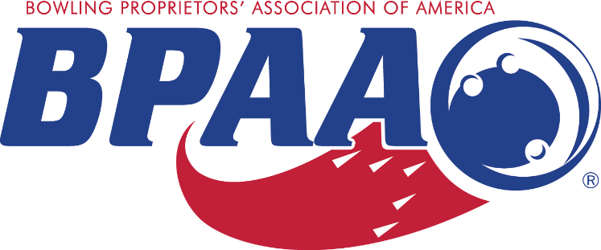

CDC Recommendations & Best Practices
It is important for operators to do what they can to ensure the safety of themselves, their team members and their guests.
- Be sure your team knows how to use the cleaning chemicals you’ve chosen. This may seem simple, but you know what they say about assumptions. Team members must be familiar with the cleaning chemicals and your specific health code requirements: intended area of use, frequency of use, and safe handling procedures. If you want to get the best possible information, contact your cleaning chemical supplier and have them educate your team on how to use their products.
- Remember that there’s a difference between “clean” and “sanitized”. A clean surface or piece of equipment would pass a visible inspection. A sanitized surface or piece of equipment is 99.9% free from bacteria.
- Team members’ personal hygiene should include washing their hands with antibacterial soap and hot water for at least 20 seconds often. The use of alcohol-based sanitizer when soap and water aren’t available is important as well.
- Encourage everyone to avoid touching their eyes, nose, and mouth.
- Close contact with people who are sick should be avoided.
- Reminder everyone to cover any coughs and/or sneezes with a tissue and throw the tissue in the trash.
- Isolate sick team members. A recent survey revealed that 90% of Americans go to work when they are sick. Operators should consider requiring sick team members to stay home.
Addressing team member fears. It is likely that some of your team members will be concerned, frightened, or even worrying about contracting COVID-19. Obviously hospitality professionals come into contact with many people from many different places. It is important to educate and inform your team members with the new Bowling University COVID-19 Prevention online On Demand course. The course only takes 20 minutes to complete and is FREE for all BPAA member centers.

